Coding Problems for practice

1) Java Arraylist
Input Format
The first line has an integer . In each of the next lines there will be an integer
denoting number of integers on that line and then there will be space-separated integers. In the next line there will be an integer denoting number of queries. Each query will consist of two integers and .
Constraints
1<=n<=20000
0<=d<=50000
1<=q<=1000
1<=x<=n
Each number will fit in signed integer.
Total number of integers in lines will not cross 100000.
Output Format
In each line, output the number located in position of line. If there is no such position, just print "ERROR!"
Sample Input
5
5 41 77 74 22 44
1 12
4 37 34 36 52
0
3 20 22 33
5
1 3
3 4
3 1
4 3
5 5
Sample Output
74
52
37
ERROR!
ERROR!

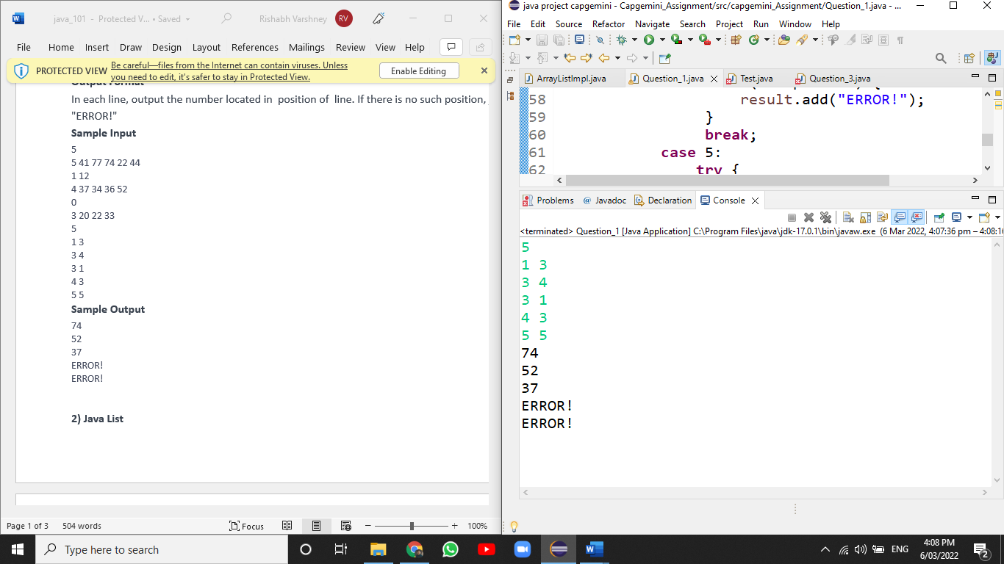

public class Question_1 {

public static void main(String[] args) throws Exception{
// TODO Auto-generated method stub
Scanner in=new Scanner(System.in);

List<Integer> list1=Arrays.asList(5,41,77,74,22,44);
List<Integer> list2=Arrays.asList(1,12);
List<Integer> list3=Arrays.asList(4,37,34,36,52);
List<Integer> list4=Arrays.asList(0);
List<Integer> list5=Arrays.asList(3,20,22,33);
ArrayList<Object> result=new ArrayList<>();

int task=in.nextInt();
for(int i=0;i<task;i++)
{
int list=in.nextInt();
int pos=in.nextInt();
switch(list) {
case 1:
try {
result.add(list1.get(pos));}
catch(Exception e) {
result.add("ERROR!");
}

break;
case 2:
try {
result.add(list2.get(pos));}
catch(Exception e) {
result.add("ERROR!");
}
break;
case 3:
try {
result.add(list3.get(pos));}
catch(Exception e) {
result.add("ERROR!");
}

break;
case 4:
try {
result.add(list4.get(pos));}
catch(Exception e) {
result.add("ERROR!");
}
break;
case 5:
try {
result.add(list5.get(pos));}
catch(Exception e) {
result.add("ERROR!");
}
break;

}
}
for(Object ele:result) {
System.out.println(ele);
}
}
}

2) Java List

Input Format
The first line contains an integer, (the initial number of elements in ).
The second line contains space-separated integers describing .
The third line contains an integer, (the number of queries).
The subsequent lines describe the queries, and each query is described over
two lines:
- If the first line of a query contains the String Insert, then the second line
- contains two space separated integers , and the value must be inserted into
- at index .
- If the first line of a query contains the String Delete, then thedexontains index , whose element must be deleted from .
Constraints
- 1<=N<=4000
- 1<=Q<=4000
- Each element in is a 32-bit integer.
Output Format
Print the updated list as a single line of space-separated integers.
Sample Input
5
12 0 1 78 12
2
Insert
5 23
Delete
0
Sample Output
0 1 78 12 23

Soluntion:-
package capgemini_Assignment;

import java.util.ArrayList;
import java.util.Scanner;

public class ArrayListImpl {

public static void main(String[] args) {
Scanner in=new Scanner(System.in);
int n=in.nextInt();
int ele;
ArrayList<Integer> list=new ArrayList<>();
for(int i=0;i<n;i++)
{
ele=in.nextInt();
list.add(ele);
}
int choose=in.nextInt();
for(int c=0;c<choose;c++)
{
String task=in.next();
if(task.equals("Insert")) {

int index=in.nextInt();
int value=in.nextInt();
list.add(index,value);
}
else {
int pos=in.nextInt();
list.remove(pos);

}

}
System.out.println(list);

}

}

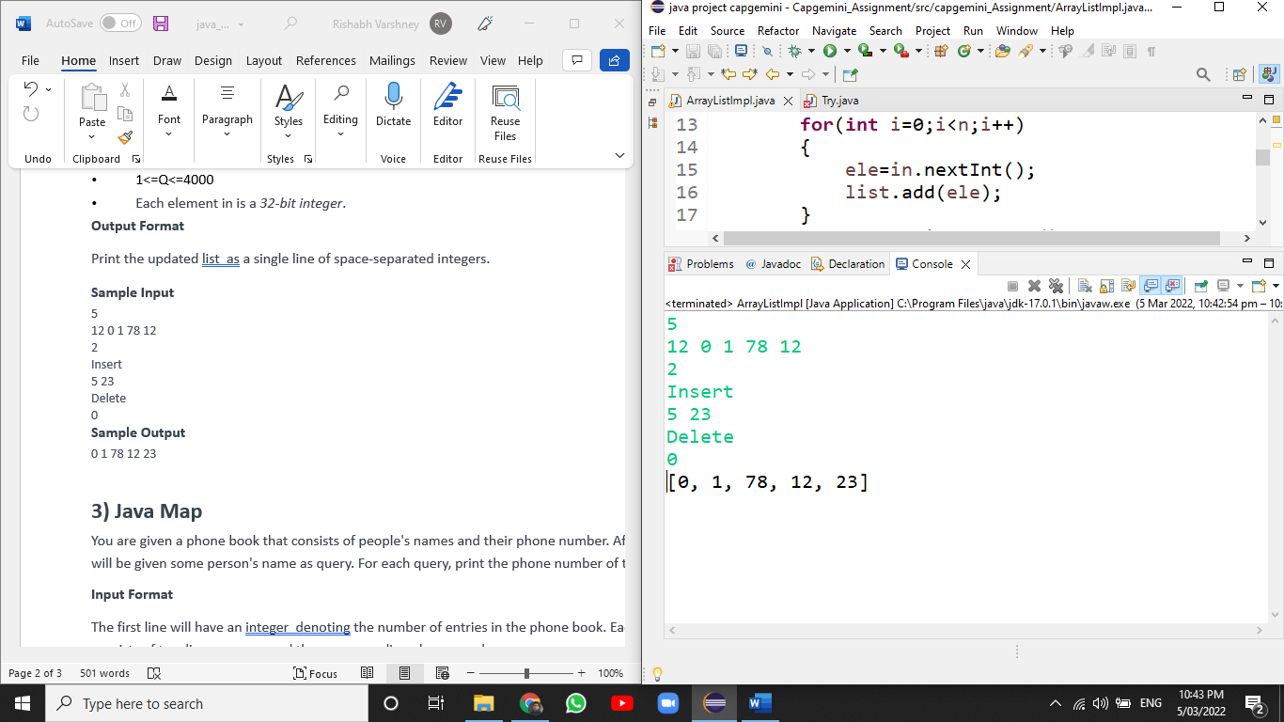

3) Java Map
You are given a phone book that consists of people's names and their phone number. After that you will be given some person's name as query. For each query, print the phone number of that person.
Input Format
The first line will have an integer denoting the number of entries in the phone book. Each entry consists of two lines: a name and the corresponding phone number.
After these, there will be some queries. Each query will contain a person's name. Read the queries until end-of-file.
Constraints:
A person's name consists of only lower-case English letters and it may be in the format 'first-name last-name' or in the format 'first-name'. Each phone number has exactly 8 digits without any leading zeros.
1<=n<=100000
1<=Query<=100000
Output Format
For each case, print "Not found" if the person has no entry in the phone book. Otherwise, print the person's name and phone number. See sample output for the exact format.
To make the problem easier, we provided a portion of the code in the editor. You can either complete that code or write completely on your own.
Sample Input
3
uncle sam
99912222
tom
11122222
harry
12299933
uncle sam
uncle tom
harry
Sample Output
uncle sam=99912222
Not found
harry=12299933

Solution:-
public class Question_3 {

public static void main(String[] args) {
// TODO Auto-generated method stub
Map<String,Integer> contact=new HashMap<>();

contact.put("uncle sam", 999912222);
contact.put("tom", 1111122222);
contact.put("harry", 333312222);
while(true)
{
String search=sc.nextLine();
if(contact.containsKey(search)==true)
{
for(Map.Entry<String, Integer> e:contact.entrySet())
{
if(e.getKey().contentEquals(search))
{
System.out.println(e.getValue());
}
}

}
else
System.out.println("Not found");
}

}

}

